1. 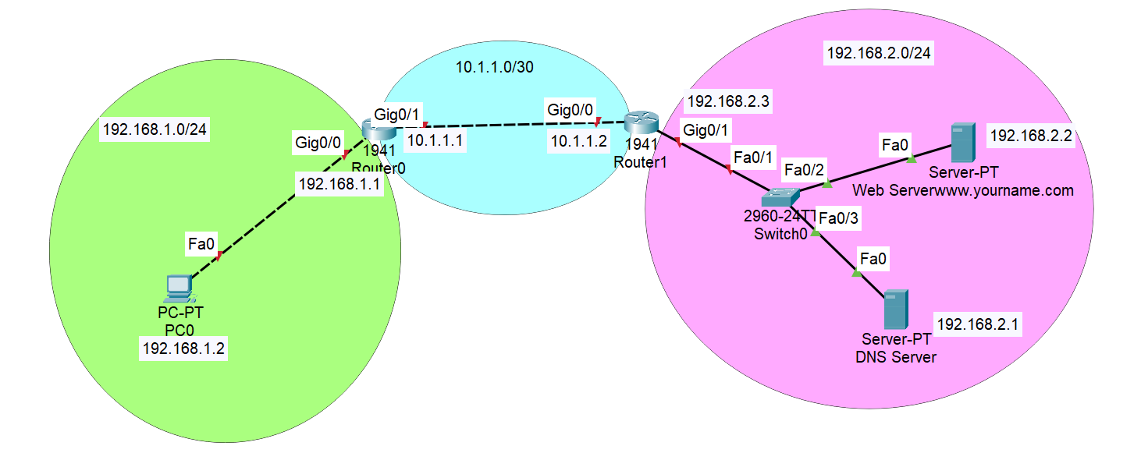Design a network according to above diagram with left network of 192.168.1.0/24, middle network with 10.1.1.0/30 and right network with 192.168.2.0/24.
2. Make a webserver in 192.168.2.2 server.
3. Assign 192.168.2.2 as [www.yourname.com](http://www.yourname.com) in DNS server.
4. Name the left router hostname as Left and right router Right.
5. Assign IP address in the router and provide static routes in the two routers according to the topology.
6. From left side n/w PC, browse www.yourname.com , if it works fine, if not troubleshoot.